**TASK #01**

1. Create a view to display records of deptno 10 from EMP table with the following attributes: empno,ename,sal, deptno.

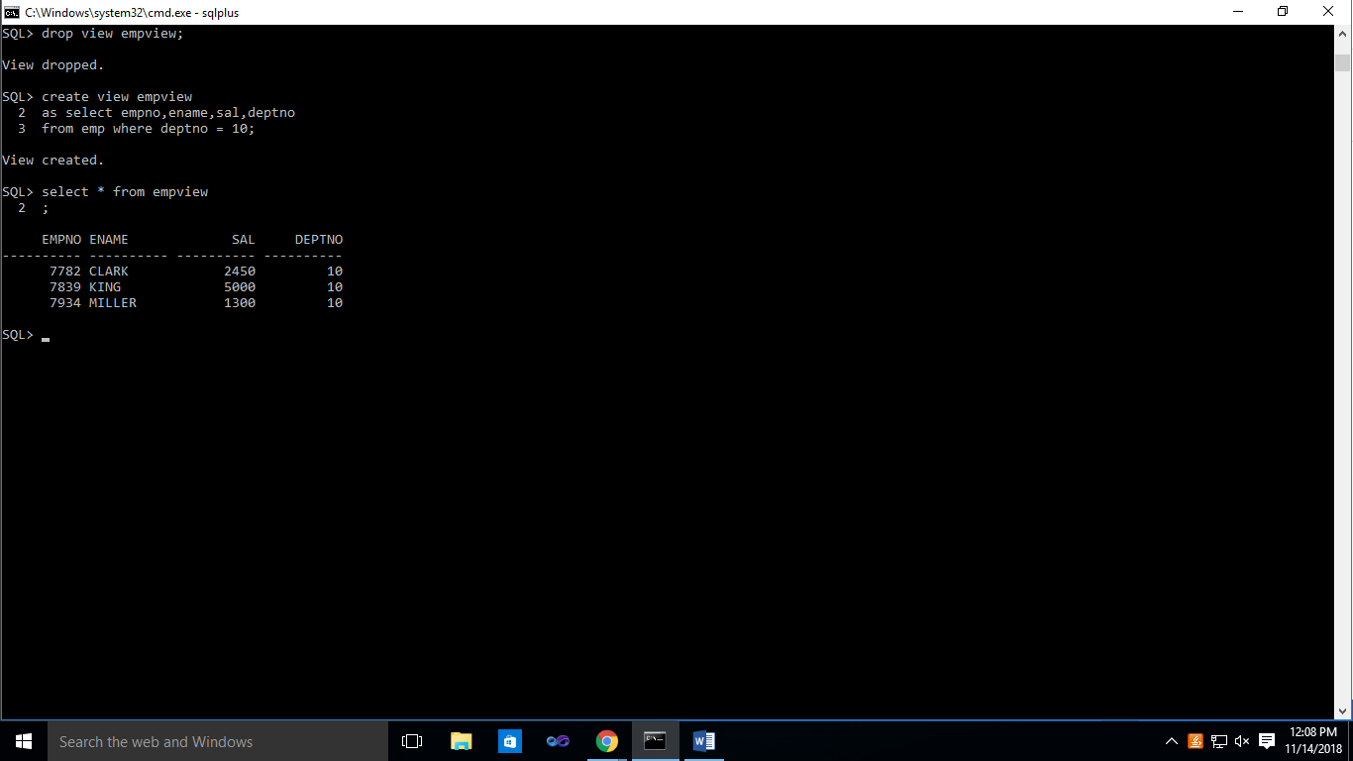

**TASK #02**

1. Display all the records from view created in question 1.

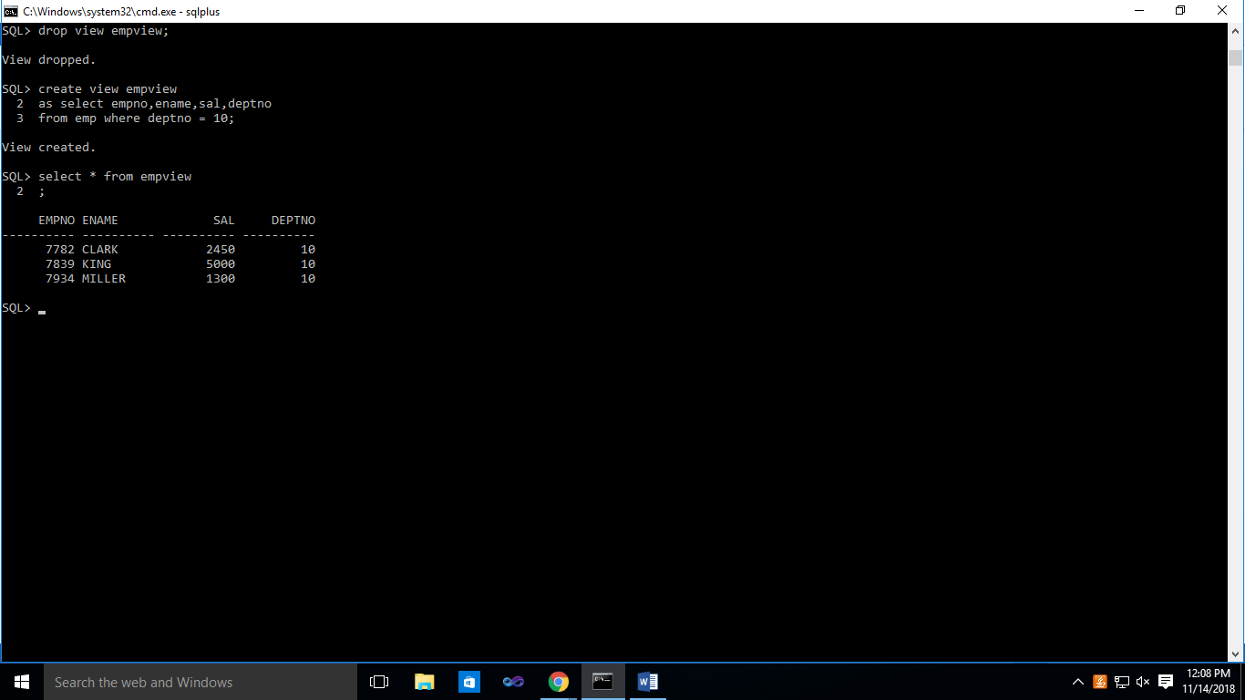

**TASK #03**

1. Through view created in question 1, update the deptno of employee 7782 from 10 to 20 and then display all the records from the same view and note which employee record is missing now, which was displayed in question 2.

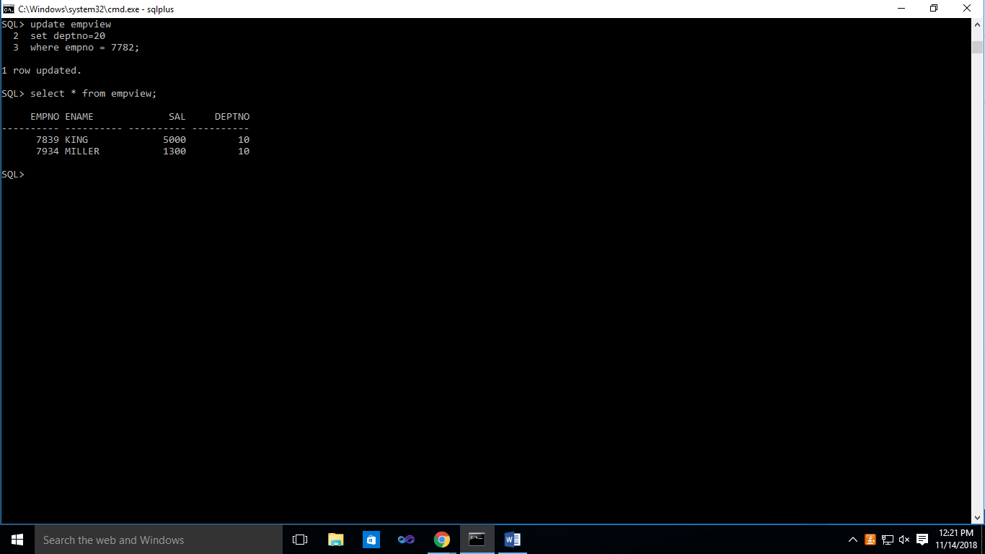

Empno 7782 is missing

**TASK #04**

1. Create any simple view with base table EMP in such a way that records can only be displayed but can never be manipulated through this view.

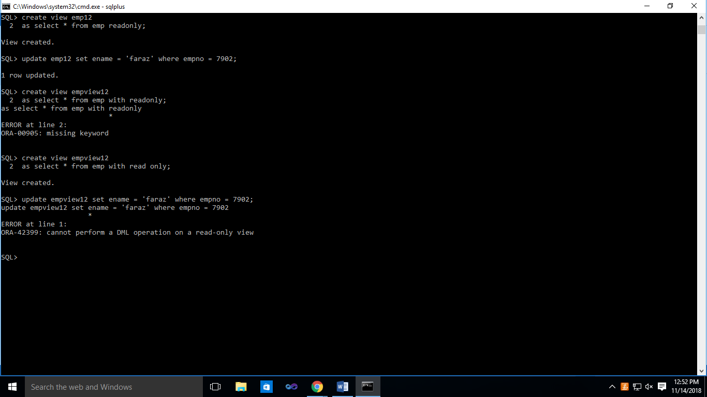

**TASK #05**

1. Create a view which displays the ename, dname and sal of all the employees of deptno 20.

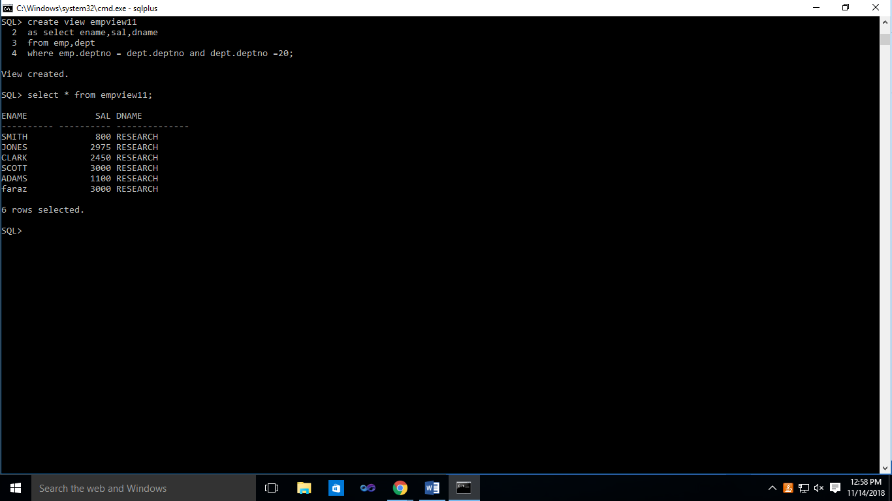

**TASK #06**

1. Create a view MY_VU based on the table EMP55 which does not exists in the schema. Now create the table EMP55 from EMP table having records of deptno=10. Now select all the records from the view MY_VU.

